Jonathon Potts, Module 6.2, “Movies” Database Setup. 11/17/2022

The first screenshot is the use of DB_Init_2022.sql:

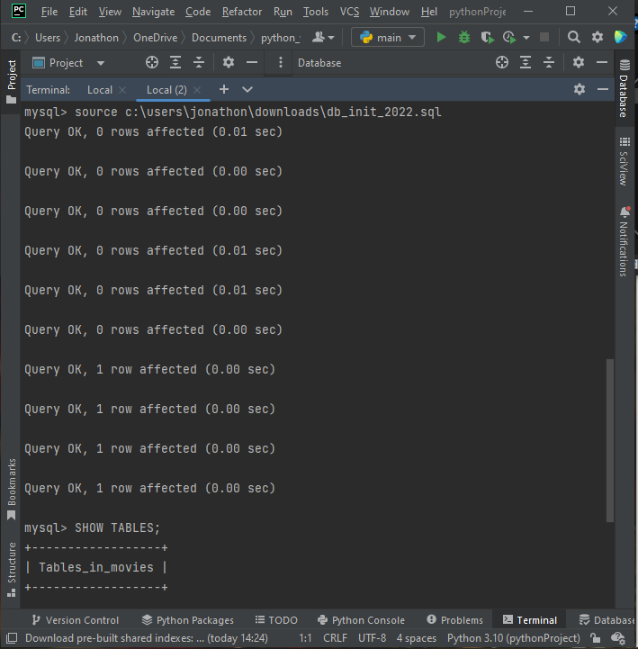

The second is the Show Tables command results:

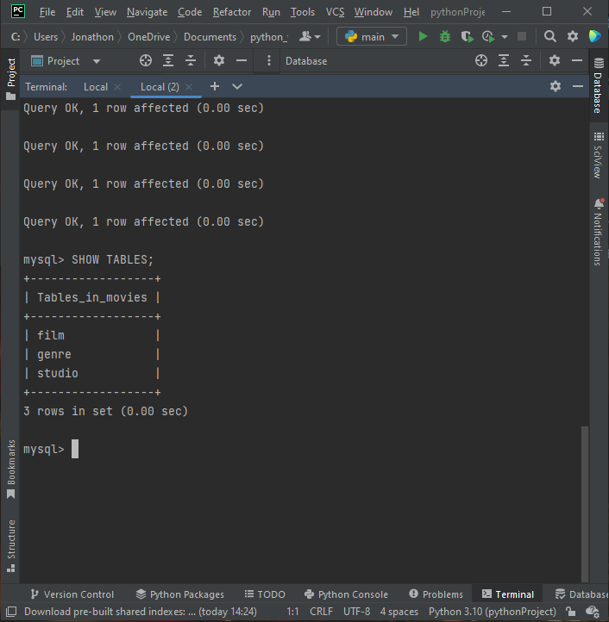

Third is the Test file output:

